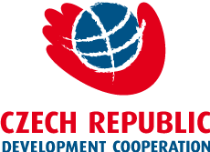

„Improvement of system of quality of primary healthcare in Georgia”

Presentation of Midterm Results of the Project

Embassy of Czech Republic to Georgia
Address: 37 Ilia Chavchavadze Ave.)
January 24, 2019

Agenda

15:00 – 15:10 - Welcome speech
Moderator – Jan Cernik, Head of Development Cooperation
- Jiří Preclík, Charge d'affaires, the Czech Embassy to Georgia
- Maia Lagvilava, Deputy Minister of Internally displaced persons from occupied territories, labour, health and social affairs
- Ekaterine Meskhrikadze, Head of Mission, Caritas Czech Republic in Georgia

15:10 – 16:10 - Presentation of project results
- Rusudan Chkhubianishvili, Project Manager
- Marina Shikhashvili, Project Lead expert of Primary healthcare
- Nato Shengelia, Project expert of Primary healthcare
- Gia Jgarkava, Project IT expert
- Tamar Ugulava, Health specialist of UNICEF
- Eka Pestvenidze, Independent Health Expert

16:10 - 17:00 - Summary, Discussion, Questions & Answers

